Hello Hiring Team,

Here are my responses to the given Exercise.

I have placed test automation project in github, please click on <https://github.com/sandeepkat/Php-Travels> to access.

I have used a new account since [demo@phptravels.com](mailto:demo@phptravels.com) has a sign in issues.

New account: username – [sandeepk.at2@gmail.com](mailto:sandeepk.at2@gmail.com)

Password - demouser

**Exercise 1:**

Implement end-to-end tests against [http://www.phptravels.net](http://www.phptravels.net/#inbox/_blank) using python, pytest, pytest-bdd, selenium, and the gherkin language for feature files.

(Here, I preferred Java over python as I am comfortable with Java language for the excercise)

**Scenario 1:** As an anonymous user who is already registered in the website, I want to be able to login and see my account page.

I have implemented the above scenario in:

/phptravels/src/test/java/steps/LoginPageTestSteps.java

**Scenario 2:** As an authenticated user, I want to be able to search for hotels for a given city, date and family size.

I have implemented the above scenario in:

/phptravels/src/test/java/steps/HomePageTestSteps.java

**Exercise 2:**

List, justify and implement at least two tests for edge cases for each scenario

from exercise 1 that ensure our website is resilient. Being resilient means it can

handle edge cases that can occur, like mistakes by the user.

I have verified all possible edge cases for login where I have seen all cases as pass.

Edge cases for Hotel search:

1. For an authenticated user, hotel search for more than a year is showing the search results. Realistically a user has to renew his stay for every month. It is a best practice to have a upper boundary for checkout date**.(MAJOR)**

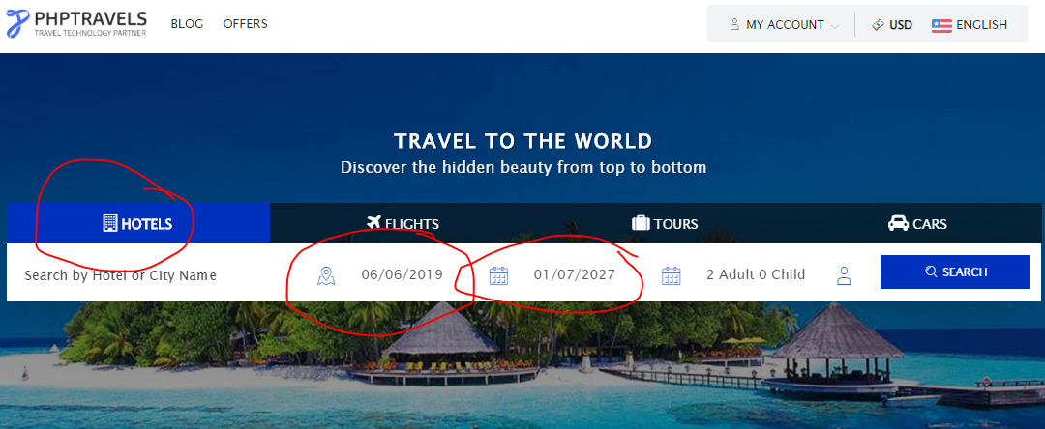

2. For an authenticated user, hotel search for a zero personal body is allowing me to see the results. It is a good practice to have a message or alert shown to enter at least one person. See below image for reference. (MINOR)

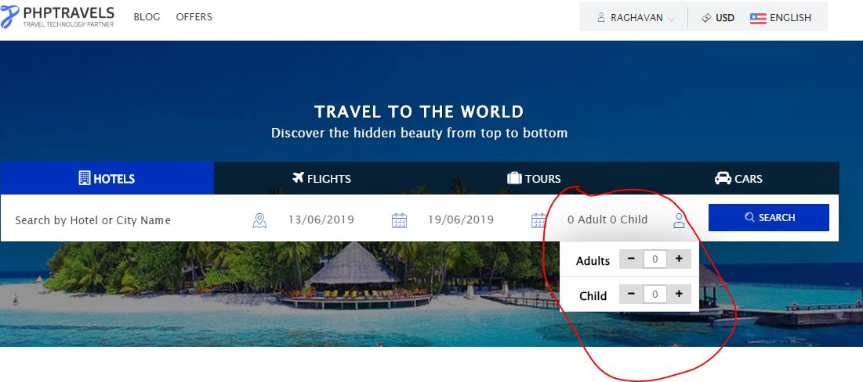

For something like a fight search, a minimum body count is one adult. See below image for reference.

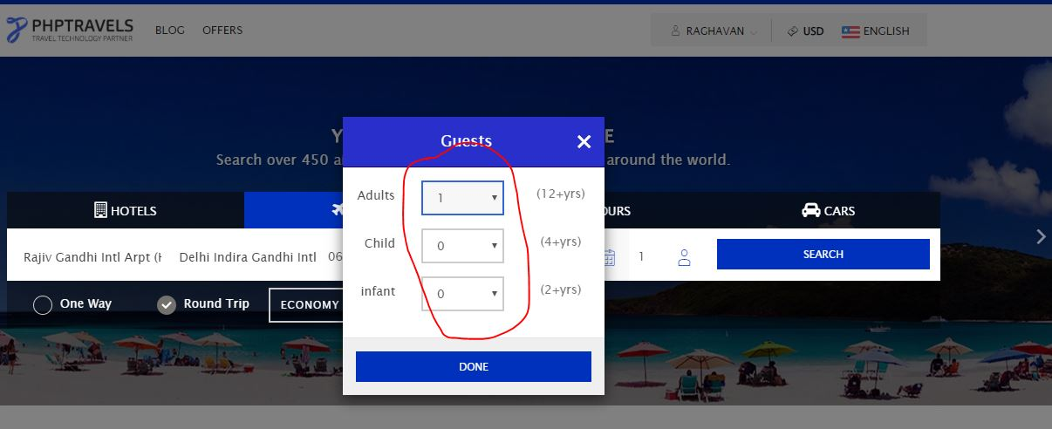

**Exercise 3:**  
 Take a look around the website and list and justify three happy paths that we

could test to ensure other core functionalities of the application are working,

and for each one, list at least two edge cases that could be tested. Choose one

of the happy paths and implement it and its edge cases.

**Three happy paths of different functionalities includes:**

* As an authenticated user, I can search for a hotel and confirm booking of the hotel. For the above scenario I have implemented in

/phptravels/src/test/java/steps/HotelBookingPageTestSteps.java class.

* As an authenticated user, I can search for a flight and view search results.

**Edge Cases:**

1. Search results without departure and arrival location, a user can see search results. Also for a round trip, departure date should be less than or equal to arrival date but the application is allowing me to choose arrival date lesser than departure date. **(CRITICAL).**

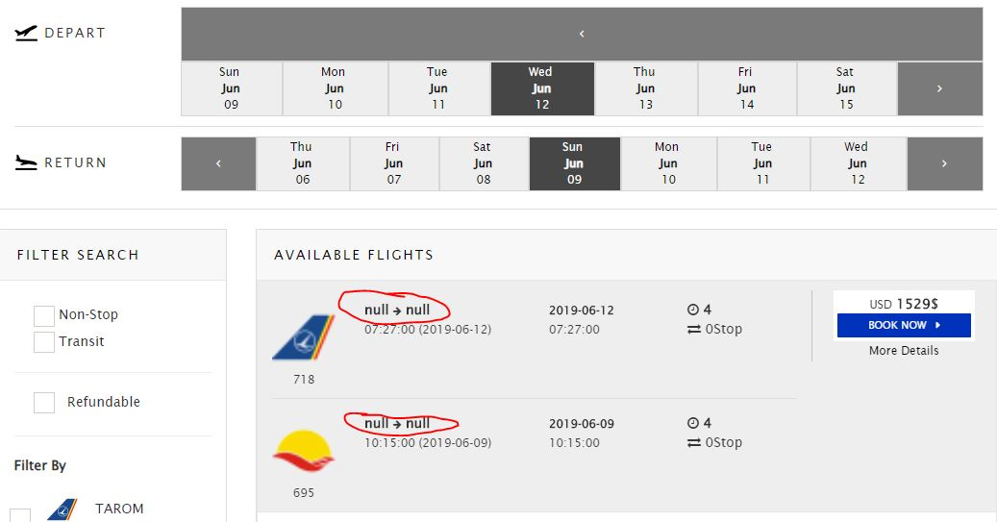

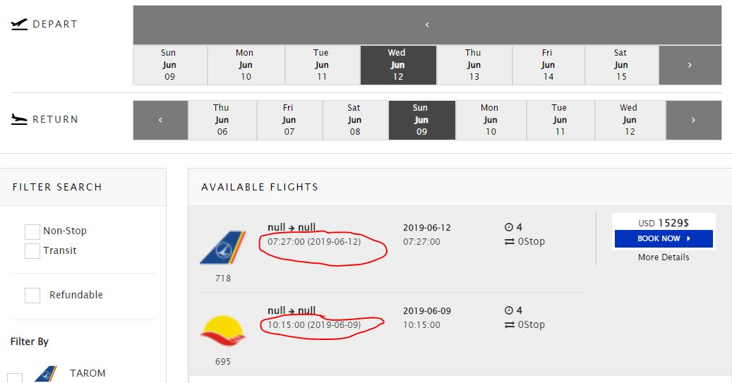

1. Search results for a single trip or round trip without the departure or arrival locations is allowing a user to see the results. It is better to have restricted to enter both the values. See below image for reference**.(MAJOR)**

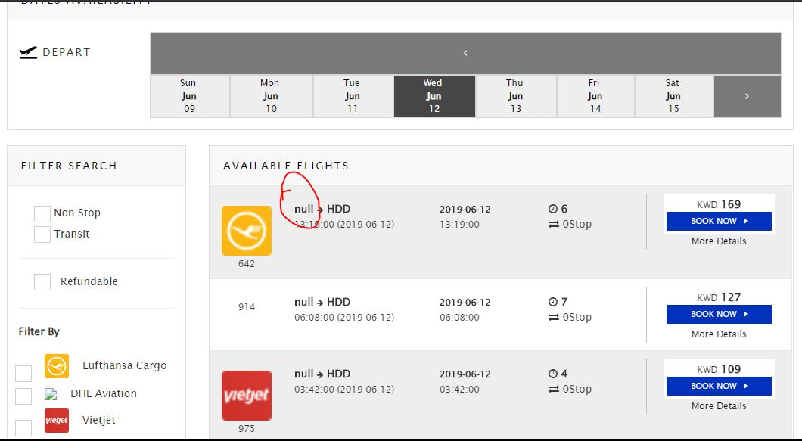

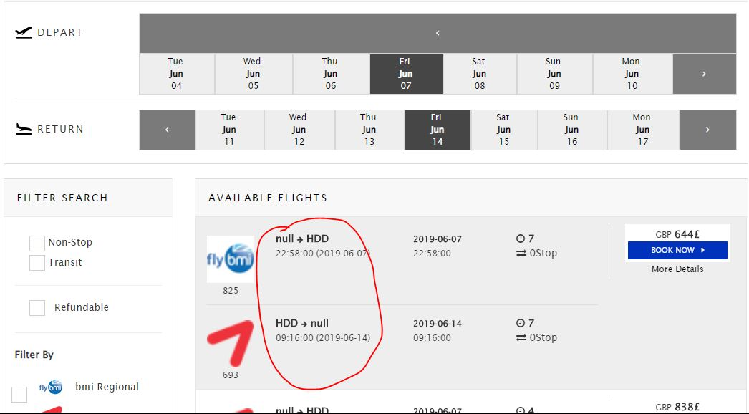

1. Search results for a single trip or round trip is allowing a user to have checkout date to be more than a year. In real world this wouldn’t be the case. See below image, it is allowing for more than a year (14 years).(**MAJOR)**

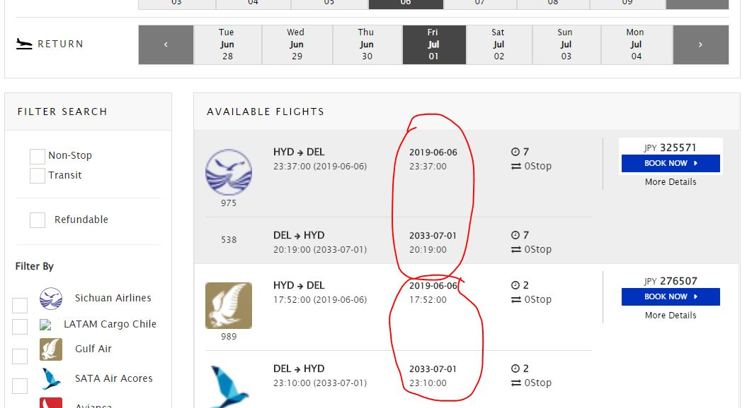

**Exercise 4:**  
Discuss what could be implemented on the application side to make the website more resilient, and if and how these improvements could be tested. Your remarks can refer to any functionality of the website, not only the ones we use for exercises 1 and 2.

**Few of the issues that I’ve observed are shown below:**

* **Security Issue: After logout of the application, we can still able to see the end point invoice of a user. (CRITICAL) see below image**

[**https://www.phptravels.net/invoice?id=1344&sessid=3271**](https://www.phptravels.net/invoice?id=1344&sessid=3271)

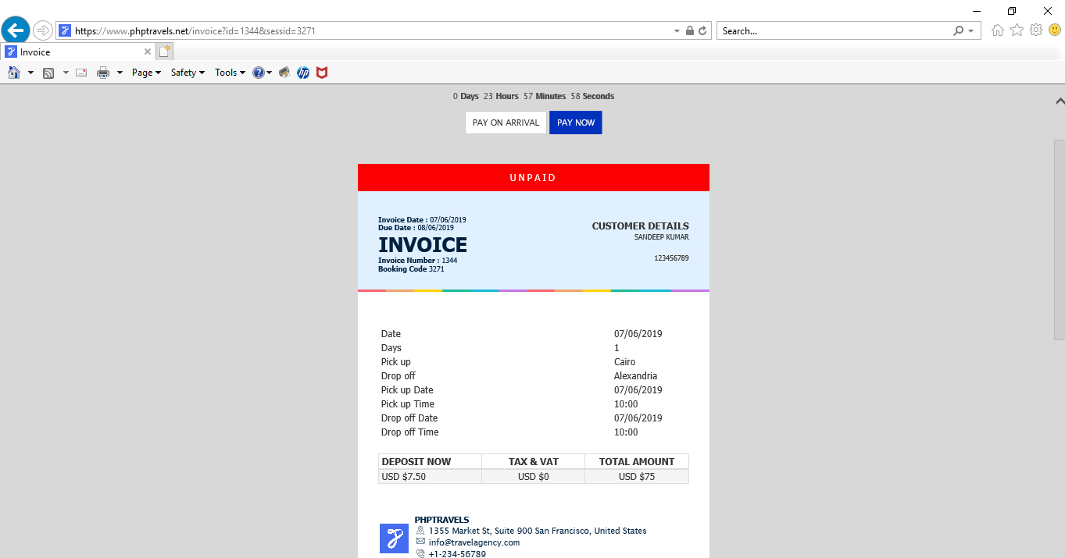

* **Account consistency issues: (CRITICAL)**

1. **Direct** [**www.phptravels.net**](http://www.phptravels.net) **url search lands me on BHAVANA account where application says that I am in BHAVANA account where as if I click on Account button it lands to login page. Also once I logged out of the application I am landing to a page under account name BHAVANA as shown below.**

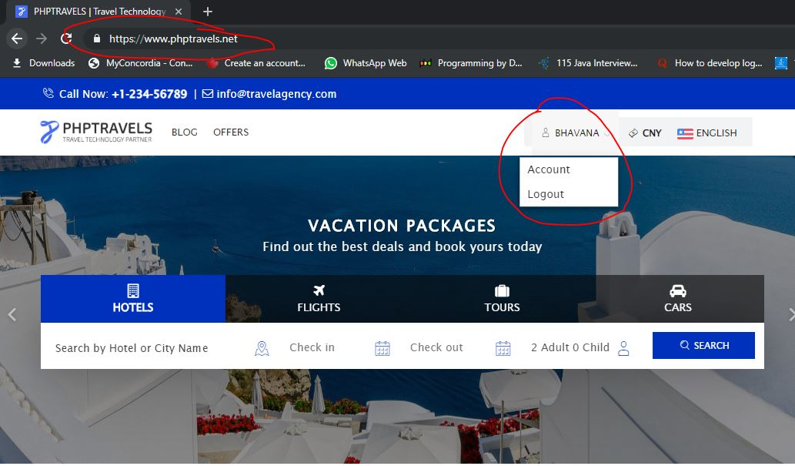

1. **Upon login, a user is landed on account page where user name is SANDEEP(self), from there if user clicks on hotels button application gives that I am JEFERSON. From there when I search for hotel I was shown SANDEEP(self) as a person currently on the page and again upon clicking flights button a user is landed to complete no person account and login button is enabled even though a user didn’t logged out. The whole above scenario is shown below. Here I would suggest to always keeping active username for the whole session. It is strongly likely that a client would go away once he gets confused with the above differences. Additionally in Automation Test scripts, I caught the above error.**

**Step 1: After login.**

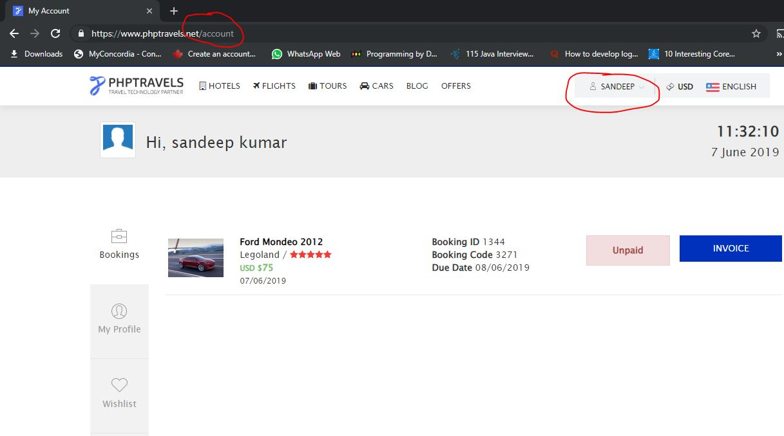

**Step 2: Click on Hotels**

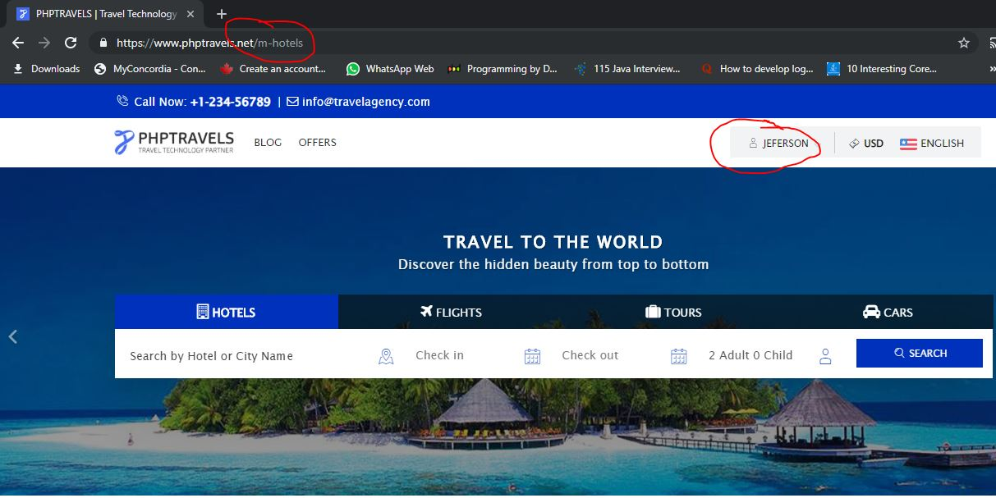

**Step 3: Hotels Search**

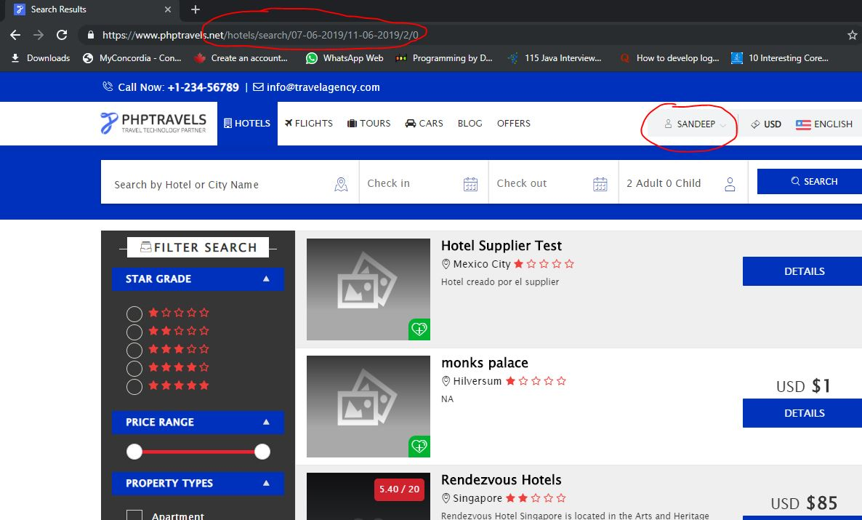

**Step 4: Click on Flights**

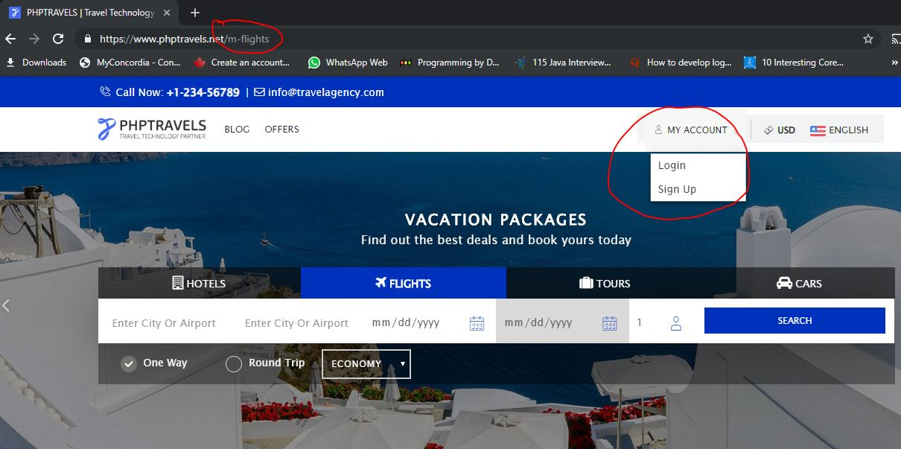

* **Performance of the application is dead slow. (MAJOR)**
* Other **basic flaws** in application are: **(MINOR)**

1. Readability for the application is very sick as change in language has many elements being not changed to the corresponding language.
   1. In flights search page, change to other language functionality totally doesn’t work.

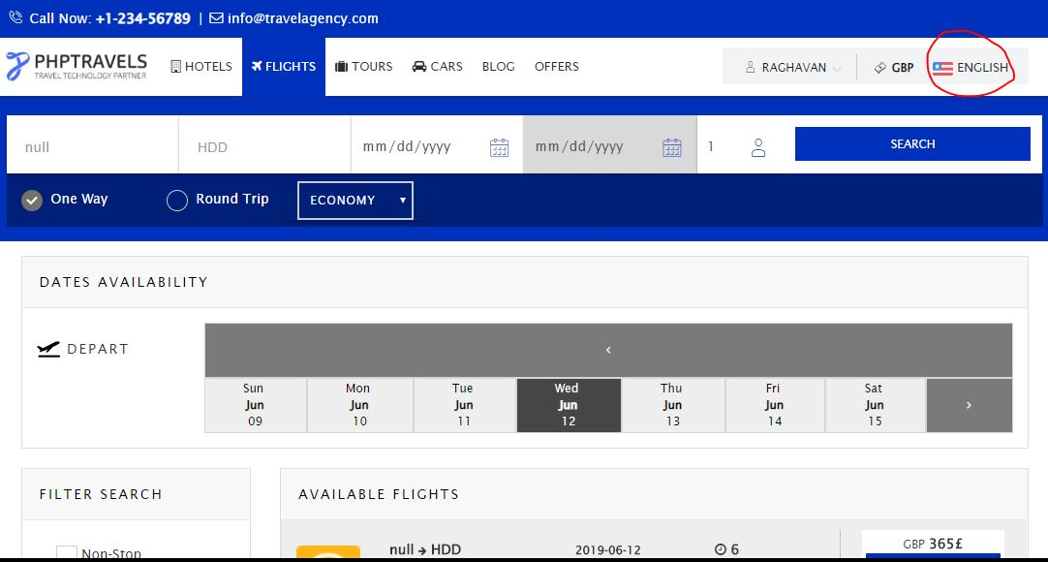

* 1. Below highlighted elements doesn’t change to French language.

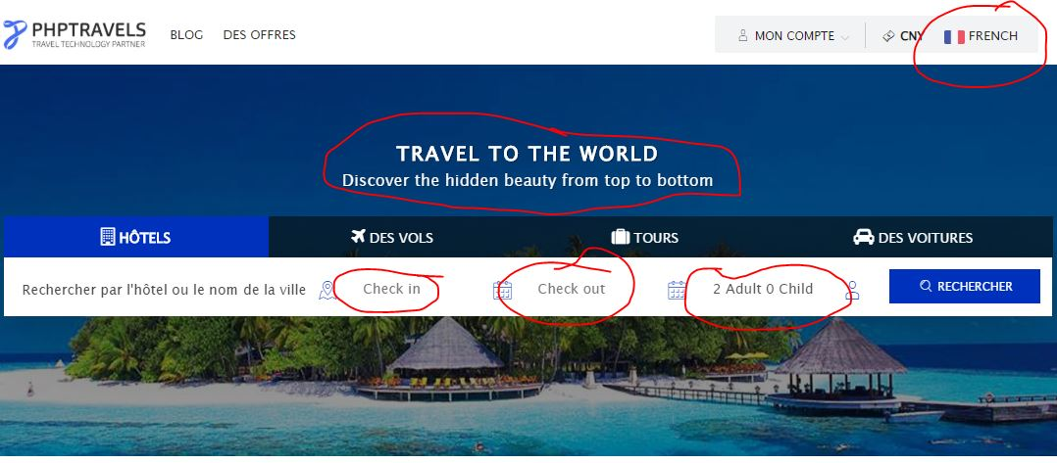

* 1. In Offers page, change to any other language has no affect on the paragraph body.

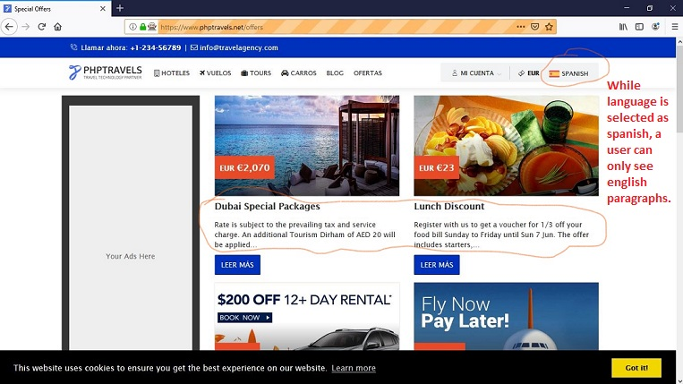

1. Once logged in, a user can see his booking details with various currencies in the list while the user profile currency is set to unique currency.

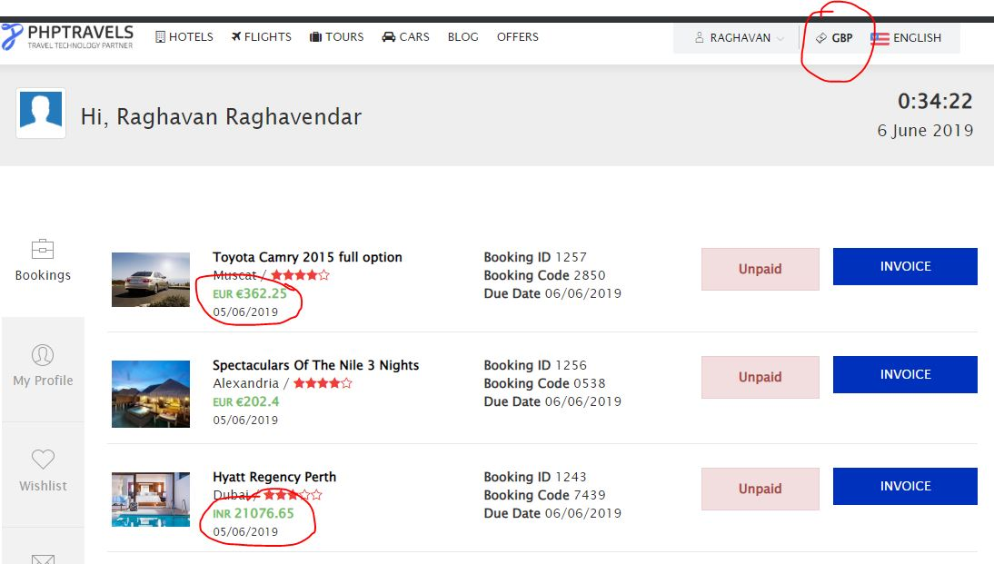

1. Upon selecting type of class in light search, a user is unable to be seeing the selection.

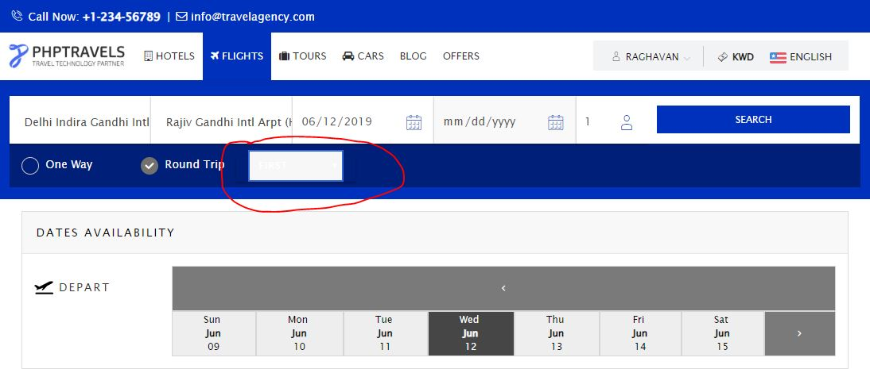

1. In hotel search results, filter functionality doesn’t work like price adjust element has no price displayed and so a user doesn’t know what he is adjusting to.

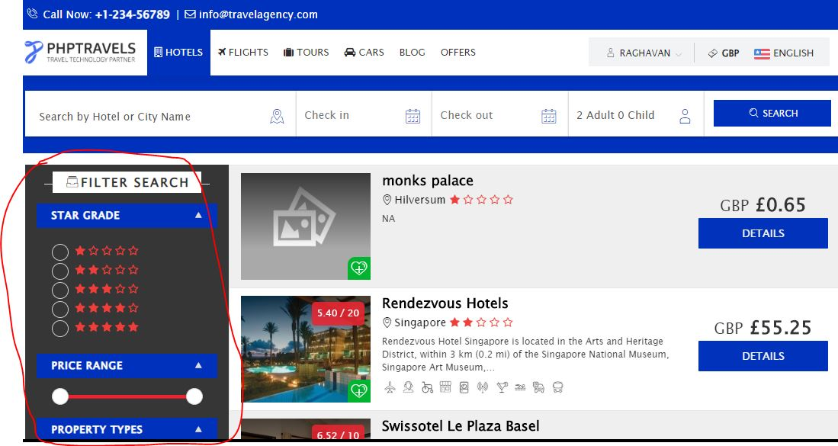

1. Maps for a specific hotel address is not stable (doesn’t work).

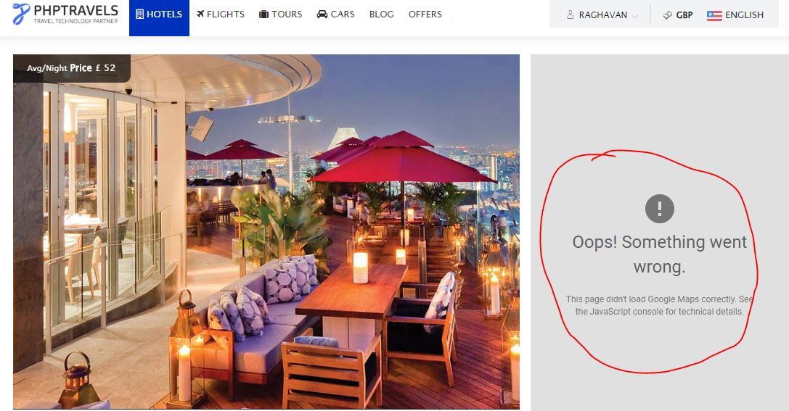

1. In profile page, it is best practice to have validity checks on mobile number and address fields. Generally, a mobile number having below 10 digits is not a valid number. For address fields, currently a user can enter any information regardless of correctness.

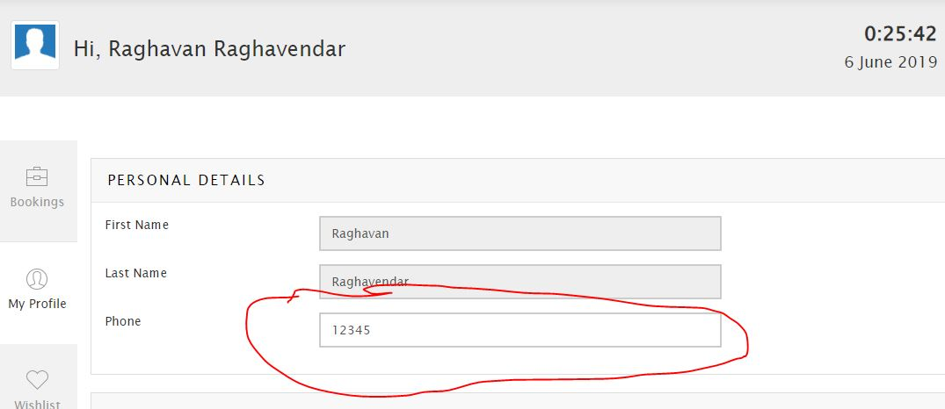

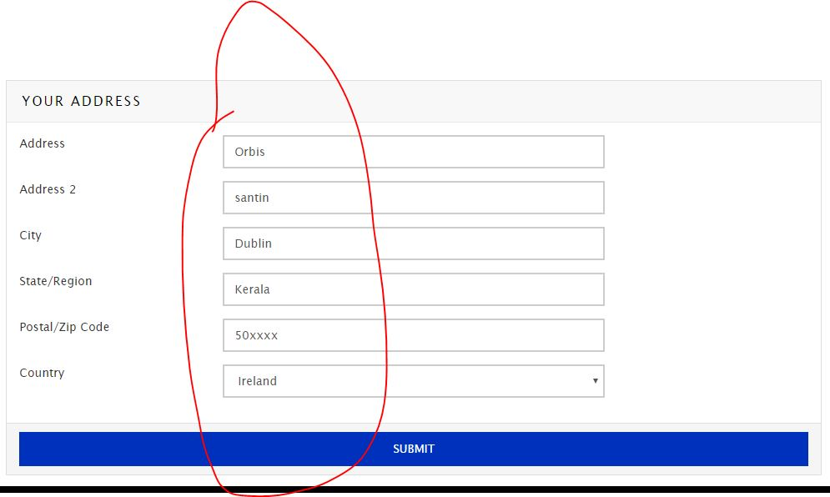

1. 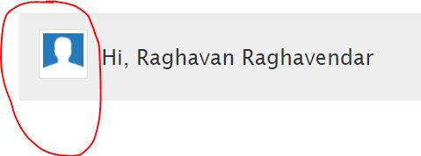For profile picture, there is no way a user can upload his picture in entire application but a space is reserved for a picture.

**QA AUTOMATION TESTER POINT OF VIEW:**

First most, every element on the web page should have a unique id’s which makes QA Automation Developer life easier and it is a best practice for developer and the Automation test cases will be stable. Application is dead slow so which requires browser to sleep until the page elements are loaded.

------------------------------------------------**Thank You**------------------------------------------